Assignment-8 Data Structures
Name-Karanveer singh
Roll no-1024200002
Branch-EEC
Ques-1)
Solution:
#include <stdio.h>
#include <stdlib.h>
#include <stdbool.h>
struct Node {
int data;
struct Node* next;
};
struct Node* stack_top = NULL;
bool isStackEmpty() {
return stack_top == NULL;
}
void push(int val) {
struct Node* newNode = (struct Node*)malloc(sizeof(struct Node));
if (newNode == NULL) {
printf("Stack Overflow.\n");
return;
}
newNode->data = val;
newNode->next = stack_top;
stack_top = newNode;
printf("PUSHED: %d\n", val);
}
void pop() {
if (isStackEmpty()) {
printf("Stack Underflow.\n");
return;
}
struct Node* temp = stack_top;
printf("POPPED: %d\n", temp->data);
stack_top = stack_top->next;
free(temp);
}
int peekStack() {
if (isStackEmpty()) {
return -1;
}
return stack_top->data;
}
void displayStack() {
if (isStackEmpty()) {
printf("Stack is empty.\n");
return;
}
struct Node* current = stack_top;
printf("Stack (Top to Bottom): ");
while (current != NULL) {
printf("%d ", current->data);
current = current->next;
}
printf("\n");
}
int main() {
printf("--- Stack Implementation ---\n");
push(10);
push(20);
push(30);
displayStack();
printf("Top element is: %d\n", peekStack());
pop();
displayStack();
pop();
pop();
pop();
printf(“Name-Paramvir Singh,Roll-1024190017,Branch-EEC”);
return 0;
}
Solution
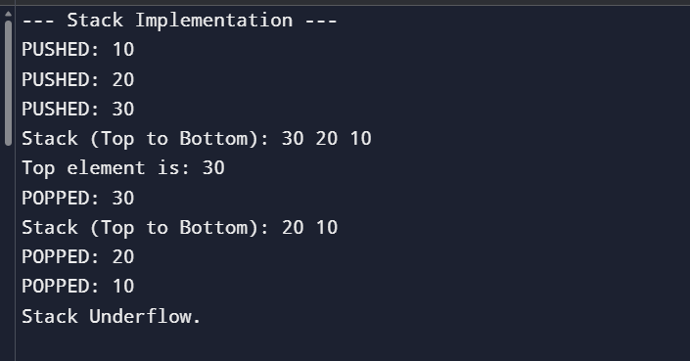
Ques-2)
Solution
#include <stdio.h>
#include <stdlib.h>
#include <stdbool.h>
struct Node {
int data;
struct Node* next;
};
struct Node* queue_front = NULL;
struct Node* queue_rear = NULL;
bool isQueueEmpty() {
return queue_front == NULL;
}
void enqueue(int val) {
struct Node* newNode = (struct Node*)malloc(sizeof(struct Node));
if (newNode == NULL) {
printf("Queue Overflow.\n");
return;
}
newNode->data = val;
newNode->next = NULL;
if (isQueueEmpty()) {
queue_front = newNode;
queue_rear = newNode;
} else {
queue_rear->next = newNode;
queue_rear = newNode;
}
printf("ENQUEUED: %d\n", val);
}

void dequeue() {
if (isQueueEmpty()) {
printf("Queue is empty. Cannot dequeue.\n");
return;
}
struct Node* temp = queue_front;
printf("DEQUEUED: %d\n", temp->data);
queue_front = queue_front->next;
if (queue_front == NULL) {
queue_rear = NULL;
}
free(temp);
}
int peekQueue() {
if (isQueueEmpty()) {
return -1;
}
return queue_front->data;
}
void displayQueue() {
if (isQueueEmpty()) {
printf("Queue is empty.\n");
return;
}

struct Node* current = queue_front;
printf("Queue (Front to Rear): ");
while (current != NULL) {
printf("%d ", current->data);
current = current->next;
}
printf("\n");
}
int main() {
printf("--- Queue Implementation ---\n");
enqueue(100);
enqueue(200);
enqueue(300);
displayQueue();
printf("Front element is: %d\n", peekQueue());
dequeue();
displayQueue();
dequeue();
dequeue();
dequeue();
printf(“Name-Paramvir Singh,Roll-1024190017,Branch-EEC”);
return 0;
}
Solution
